Unit 6 Southeast Asia
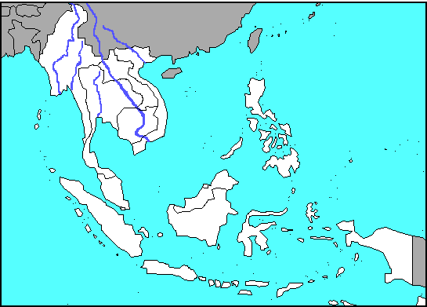

Geography:
Countries: Indonesia, Malaysia, Thailand, Laos, Cambodia, Vietnam, Singapore, Philippines, Mynamar
Waters: South China Sea, Philippine Sea, Andaman Sea, Java Sea, Banda Sea, Celebes Sea, Pacific Ocean, Indian Ocean, Gulf of Tonkin, Gulf of Thailand, Gulf of Martaban, Bay of Bengal, Strait of Malacca
Rivers: Irrawady, Chao Phraya, Mekong, Red
Islands: Philippines, Sumatra, Java, Borneo, Celebes, New Guinea
Cities: Rangoon, Bangkok, Hanoi, Kuala Lampur, Jakarta, Manila

