Unit 1
Geography Study Map
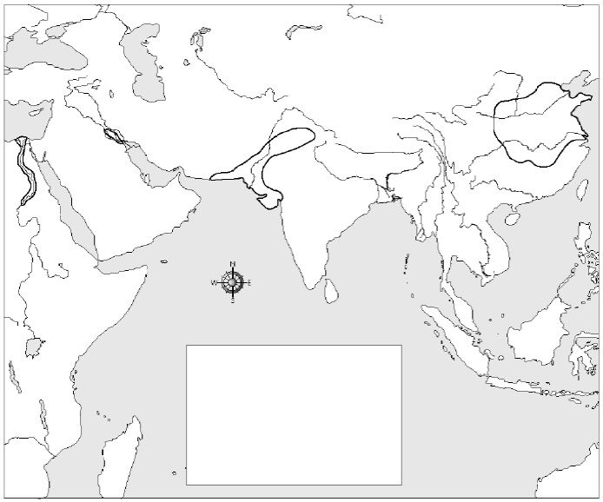
Geography Elements
Tiger River Ur Persian Gulf
Euphrates River Babylon Red Sea
Nile River Memphis Mediterranean Sea
Ganges River Giza Zagros Mountains
Indus River Harappa Arabian Sea
Yellow River Laoyang Bay of Bengal
Yangtze River Anyang Yellow Sea

