Map of India and Middle East with Silk Road

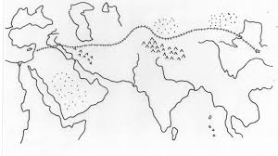

Bay of Bengal Kalinga
Indian Ocean Indus
Thar Desert Ganges
Saudi Arabia Ceylon
Arabian Sea Himalayan Mountains

