Unit 7 World Exploration
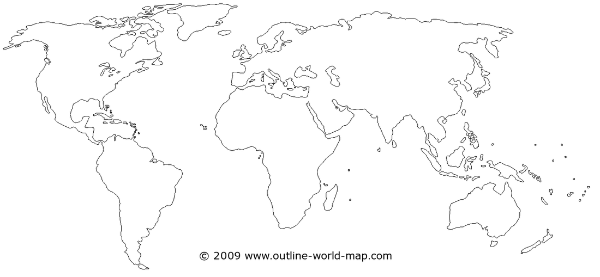
Chart the Voyages of the following on one map (including dates). Use different colors to highlight the differences
Dias Pizarro
Da Gama Carter
Columbus Zheng He
Magellan Albuquerque
Cortez

