Geography China
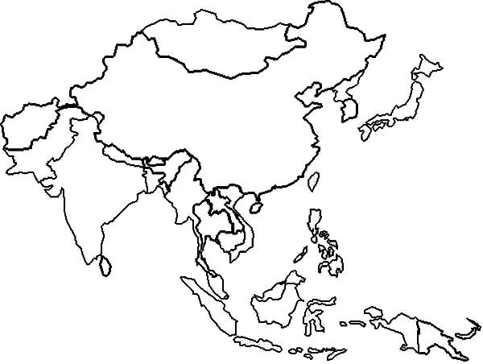

Yellow Sea East China Sea South China Sea Bohai Gulf Gulf of Tonkin
Huange He (Yellow) Yangtze River Chang Jiang Pearl River Songhua River
Mekong River Brahmaputra River Mongolian Plateau Tibet Plateau Gobi Desert
Takla Makan Desert Hainan Taiwan
Beijing Tianjin Shanghai Xi’an Guangzhou
Hong Kong Taipei

