Geography and Study Help
Unit 2

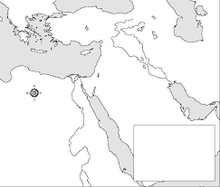

Assignment: Print this map and place the geography elements from the Handout on this map

