Australia Map
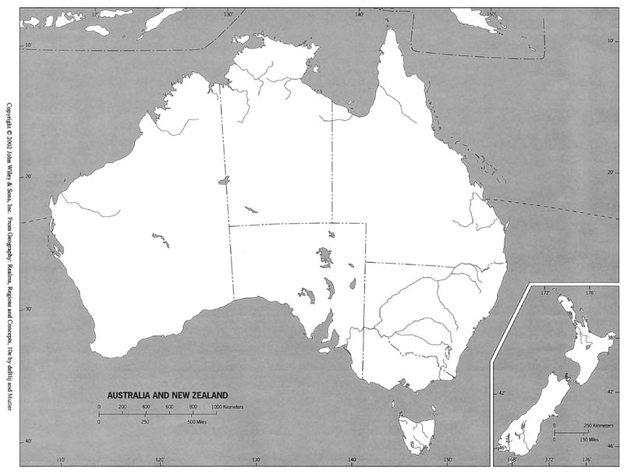

Indian Ocean Tasmania Canberra
Pacific Ocean New Zealand Sydney
Southern Ocean Murray River Melbourne
Tasman Sea Darling River Perth
Coral Sea Cooper Creek
Great Barrier Reef Lake Eyre
Gulf of Carpentaria Great Dividing Range
Grand Australian Bight Great Victorian Desert
Bass Strait Great Sandy Desert

