Unit 4
Roman Empire
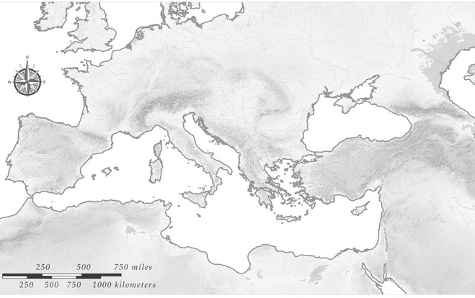

Mediterranean Sea Spain Rhine River
Rome Gaul Danube River
Carthage Alps Constantinople
Sicily Palestine
Tiber River Jerusalem

